Symentic Woods

Symentic Woods - is a popular furniture manufacturing company. As part of their business process, they provide delivery service to the retailers on request. The company gets numerous order requests and processing them manually takes enormous time. Develop a web page for them to calculate the total bill amount for each order placed, which includes the product cost based on quality and delivery charges. On furnishing all the necessary details and confirming the order, message on the total bill amount must be displayed on the same page as shown in the screen shots below.

Plain web page:

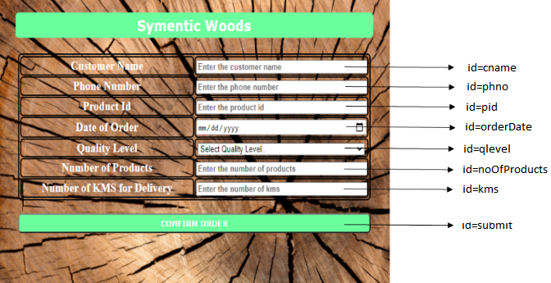
Web page after furnishing all details and clicking on CONFIRM ORDER button.
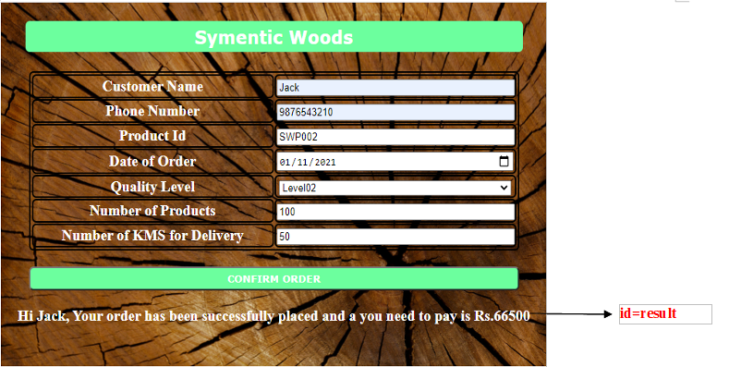

Use the Label Name and the Component Id as given. All the necessary attributes for the Components should be given. The Component Id should be specified for each HTML Component. If the Component Id is not provided for an HTML component, marks will not be provided for that component. All Tags, Elements and Attributes should conform to HTML5 Standards.
Provide the details as given in the table below.
Req. # | Req. Name | Req. Description
1 | Design an HTML page for “Symentic Woods” application | Note: The text highlighted in bold in the Description needs to be implemented in the code to complete the web page design.
  Label Name | Component Id  (Specify it for the “id” attribute) | Description
  Customer Name | cname | To enter the name of the customer.  Design Constraints:  - The text “Enter the customer name” should appear by default.  - It should be mandatory.  - Use type=“text” with pattern attributes to accept the alphabets and space only.
  Phone Number | phno | To enter the phone number of the customer.  Design Constraints:  - The text “Enter the phone number” should appear by default.  - It should be mandatory.  - Use type=“tel” or use type=“text” with pattern attributes to accept the 10 digit mobile number that starts with either one of the following numbers: 7,8 or 9
  Product Id | pid | To enter the product id.  Design Constraints:  - The text “Enter the product id” should appear by default.  - It should be mandatory.  - use type=“text”
  Date of Order | orderdate | To enter the order date.  Design Constraints:  - Use type=“date”  - It should be mandatory.
  Quality Level | qlevel | To select the quality level.  Design Constraints  Use the drop down box with “Select Quality Level..”, “Level01”, ”Level02” and “Level03” as options.  The field is mandatory.
  Number of Products | noOfProducts | To enter the number of products.  Design Constraints:  - The text “Enter the number of products” should appear by default.  - It should be mandatory.  - Use type=“number”
  Number of KMS for Delivery | kms | To enter the number of kms.  Design Constraints:  - The text “Enter the number of kms” should appear by default.  - It should be mandatory.  - Use type=“number”
   | submit | Submit button to submit the form  Design Constraints  - The input type should be “submit” and the value should be “CONFIRM ORDER”
2 | Apply the mentioned styles using CSS to the components | STYLING WITH ELEMENT SELECTORS  - HEADING should be specified using <h3> tag.  Its color must be #FFFFFF and the background-color must be #66FF99.  The margins: margin-left and margin-right must be auto.  The text-align must be center and width 50%.  The font-family of the text must be Verdana.  The padding and border-radius must be 5px and 6px respectively.  - TABLE , tr and td must be styled with width as 50% and border-style must be solid 1px.  The margins: margin-left and margin-right must be auto.  The border-spacing and border-radius must be 1px and 6px respectively.  Its color must be #FFFFFF and the background-color must be transparent.  The padding must be 1px.  STYLING WITH ID SELECTOR  SUBMIT component must be styled using it’s id as in :  Its color must be #FFFFFF and the background-color must be #66FF99.  The margins: margin-left and margin-right must be auto.  The padding must be 5px and width must be 50%.  The font-family of the text must be Verdana and font-weight must be bold.  The border-radius must be 6px.  RESULT component must be styled using it’s id as in :  Its color must be #FFFFFF and the font-size must be 20px.  Note: Fill in the style tag so as to have the given styles applied to the components. (Do not use Inline CSS)
3 | Use JavaScript for displaying the bill details. | Use JavaScript for displaying the bill details:  When the valid values are entered and the “CONFIRM ORDER” button is clicked, the bill amount should be displayed as follows:  Hi customerName, Your order has been successfully placed and you need to pay is Rs. totalBillAmount  - in a div tag with id as “result”.  If the product quality (for a particular product) chosen is Level01, base cost of that product is increased by 20% for each piece.  If the product quality (for a particular product) chosen is Level02, base cost of that product is increased by 10% for each piece.  If the product quality (for a particular product) chosen is Level03, base cost of that product is unchanged.  Example for reference:  If order for 100 pieces of Level02 quality product with ID-SWP002 is placed by a retailer who is 50 kms away, then  Cost for 1 piece after applying 10% extra cost = 600 + (10 % of 600) = Rs. 660  Cost for 100 piece = 660 * 100 = Rs. 66000  Delivery cost = 50 * 10 = Rs. 500  Total bill amount = 66000 + 500 = Rs.66500  Note:  - Use the getElementById() function to retrieve the values.  - In Javascript, Please do not use “let”. Instead, use “var”.
  ProductID | Base cost per product | Delivery cost per km
  SWP001 | 500 | 8
  SWP002 | 600 | 10
  SWP003 | 800 | 11
  SWP004 | 1200 | 13
4 | form Tag with attribute onsubmit | form Tag is already given in the code template. Do not change the code template and do the coding as per the requirements and specification.  Make sure that the onsubmit attribute in the form tag invokes the JavaScript function like "return display()". Also ensure that the “return false;” statement should be the last line of the JavaScript function “display()”.

My output:
